Ramiro Francisco Batallas

[Email address]

Sitecore Hackathon 2021

Website developer with Sitecore 10.1

Wolfensteing team

Installation Instructions

# Installation Instructions

1. Install Sitecore 10.1 <https://sitecoredev.azureedge.net/~/media/A76121649BE84CAD8DECAD641D307C32.ashx?date=20210222T221044>
2. Go to <https://github.com/Sitecore-Hackathon/2021-Wolfenstein/tree/main/src/Project/Wolfenstein.WebSite/sitecore/shell/Controls/Rich%20Text%20Editor>
3. Download all files in the previous URL.

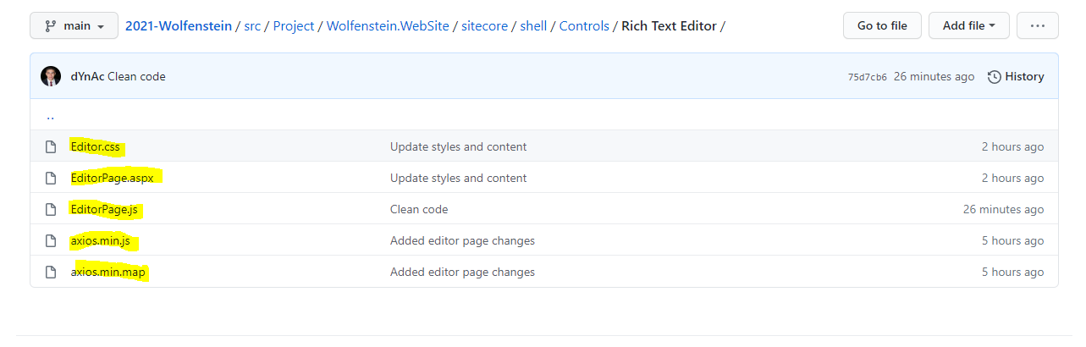

1. Go to following website directory \inetpub\wwwroot\<your Website>\sitecore\shell\Controls\Rich Text Editor.
2. Copy and replace all files.

